Individual Report for OOSD
During this project, our group was required to design and implement an accommodation system using a range of tools including Astah UML, NetBeans, Java and, JavaFX. The system would include a graphical user interface that allows different users (manager, warden and student) to edit, supervise or view room details respectively. We divided the required tasks between team members and followed Agile practices to ensure effective and efficient working techniques. The main factors of agile development that our team considered whilst developing this system included collaborative meetings and interim deadlines. Following these practices helped our group to stay on track during the project and to make sure all members of the team knew their roles and responsibility at all times.

First, our group were required to utilise a unified modelling language tool to create a range of diagrams to represent our system. We designed a use case diagram to identify system users and to avoid building the wrong solution for the specification. As a group, we individually designed our own use case diagram before comparing results and combining the diagrams to ensure that the final model included all of the requirements of the specification. I was responsible for aiding the design of the diagram and for proof checking the final version. Next, we were required to design a class diagram to distinguish the relevant nouns from the scenario that represented the classes needed for this application. Again, we individually designed our own class diagrams and then combined ideas to form our final model. Finally for this section, we used sequence diagrams to model the interactions between the classes in a single use case. We each created our own sequence diagram for a chosen use case. I chose ‘create lease’ and designed a comprehensive sequence diagram to represent how the classes interact with each other and the order in which the interactions occur.
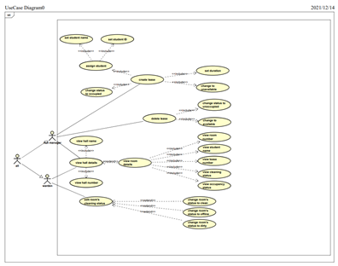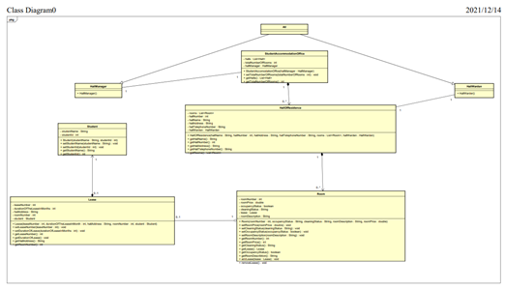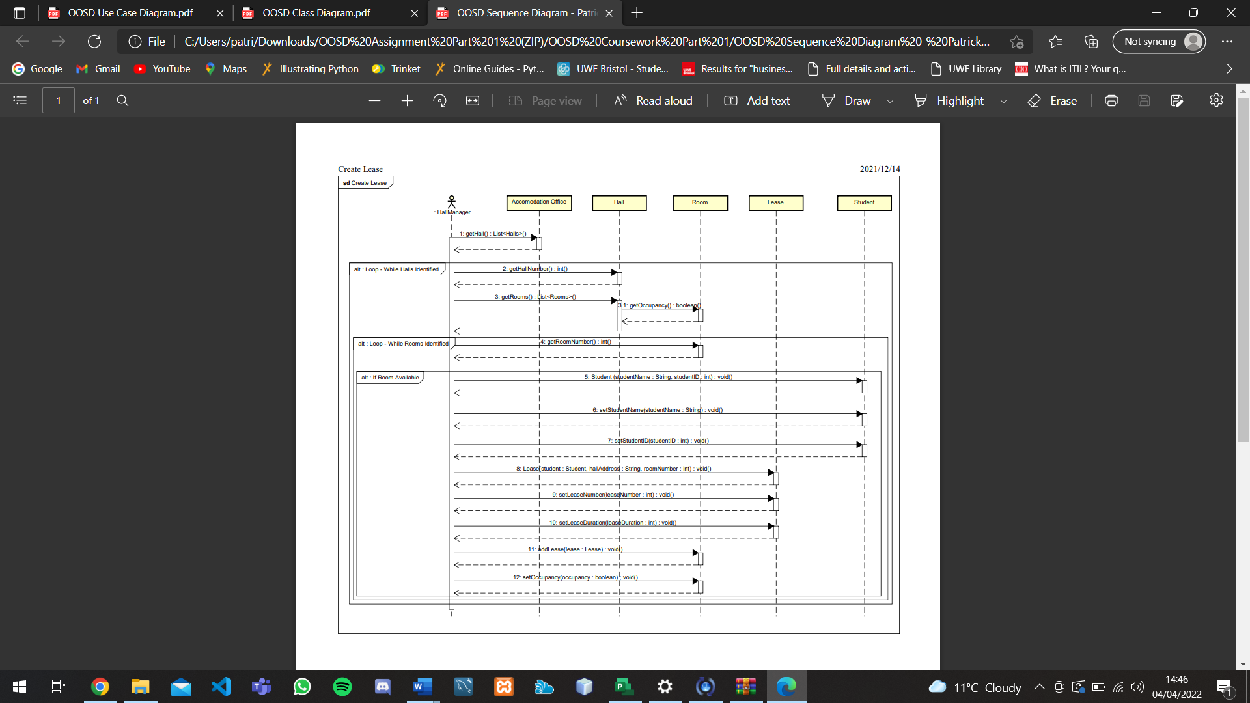

Once our diagrams had been successfully created, the next step was to implement the system. We used Java, JavaFX and SceneBuilder to create the graphical user interface. I assisted my team during the development and tried to help as much as possible with any issues that arose. This was made easy by following agile practices with frequent team meetings either in person or online. Weekly meetings also ensured that all members of the group were aware of their responsibilities and roles at all times. I was responsible for writing the agile report for our project. For this report, I had to consider the advantages of agile development against old methodologies and detail how we utilised this technique to our advantage during the project. I researched other similar project management methodologies and compared the differences. From my findings, I decided that Agile was the ideal methodology for this project due to its flexibility which allowed for changes to the system over time. It also highlighted the importance of frequent collaborative meetings; these were crucial during the development of our system.

Overall, during this project I gained a better understanding of Java, JavaFX, Scenebuilder and UML modelling tools. I believe that across this module I learnt how to use UML models effectively to design an object-oriented system. My knowledge of JavaFX and Scenebuilder before this module was not great as I had never utilised them. However, I now feel confident enough to continue to develop more of my own GUI’s and further my understanding of everything from the design to the implementation stage.

